**A**

**MINI PROJECT REPORT**

**ON**

**“THE EMPORIUM”**

**SUBMITTED BY**

**Mr. Dhananjay Manik Bhagat**

**(SPPU Exam Seat No. 5614)**

**D.Y. PATIL INSTITUTE OF MCA AND MANAGEMENT**

**AKURDI, PUNE-411044**

**Academic Year 2022-2023**

****Dr. D. Y. Patil Pratishthan’s

**D.Y. Patil Institute of Master of Computer Applications**

**And Management**

Sector No.29, Behind Akurdi Railway Station, Pradhikaran, Nigdi, Pune – 411044

Tel No: 020-27640998, 202737393, Fax no: 27653054, Website: www.dypimca.ac.in,

Email: director@dypimca.ac.in

**(Approved by AICTE, Recognized by DTE, Mah.; Affiliated to SPPU)**

**Ref:** DYPIMCAM/Acad/Note/ 100/23 Date: 03/08/2023

**CERTIFICATE**

This is to certify that the Project entitled

**“THE EMPORIUM”**

Has been successfully completed

By

**Mr. Dhananjay Manik Bhagat**

Towards the partial fulfillment of

M.C.A. (Master of Computer Application)

Under

Savitribai Phule PuneUniversity for

Academic Year 2022-2023

**Mr. Rahul Ambapkar**

**Project Guide Internal Examiner**

**Dr. Kavita Suryawanshi Dr. K Nirmala**

**HOD-MCA, Vice Principal Director**

**External Examiner**

**Acknowledgement**

I would take the opportunity to thank **Dr. K. Nirmala, Director, DYPIMCA and Management** for her support, extended to me throughout the course.

I would like to thank **Dr. Kavita Suryawanshi, Vice Principal,** for her scholarly disposition, timely guidance, support and cooperation.

I would like to thank **Mr. Rahul Ambapkar** for herkind guidance, keen interest, continuous encouragement and inspiration throughout the project work.

Finally, I gratefully thank all the faculty members of DYPIMCA and Management for their cooperation and support.

I also thankful to get constant encouragement, support and guidance from all Teaching and Non- Teaching Staff for their timely support which helped us in successfully completion of our project work.

Student Sign:

Student Name : Dhananjay Manik Bhagat

MCA I

Div- C

Roll No : 149

Seat No : 5614

**Dr. D. Y. Patil Pratishthan’s**

**D. Y. Patil Institute of Master of Computer Applications and Management**

**(M.C.A. Programme)**

(Approved by AICTE, New Delhi & Affiliated to Savitribai Phule Pune University)

**Dr. D. Y. Patil Educational Complex, Sector 29, Pradhikaran, Akurdi, Pune – 411 044**Tel No: (020)27640998, Website: www.dypimca.ac.in, E-mail : [director@dypimca.ac](mailto:director@dypimca.ac).

**Index**

|  |  |  |
| --- | --- | --- |
| Sr. No | Chapter Name | Page No |
| **1** | **Chapter 1: Introduction** | 6 |
| 1.1 | Project Objectives | 7 |
| 1.2 | Existing System and Need of System | 8 |
| 1.3 | Scope of work | 9 |
| 1.4 | Operating Environment-Hardware and Software | 10 |
| 1.5 | Technology Used | 10 |
| 1.6 | Module Specification | 11 |
| **2** | **Chapter 2: Analysis & Design** | 12 |
| 2.1 | Data Flow Diagram | 13 |
| 2.2 | Entity Relationship Diagram | 16 |
| 2.3 | Use Case Diagram | 17 |
| 2.4 | Activity Diagram | 18 |
| 2.5 | Sequence Diagram | 19 |
| 2.6 | Class Diagram | 20 |
| 2.7 | User Interface Screens | 21-27 |
| 2.8 | Table Structure | 28-30 |
| 2.9 | Analytical Report | 31 |
| **3** | **Drawbacks and Limitations** | 33 |
| **4** | **Proposed Enhancement** | 35 |
| **5** | **Conclusion** | 36 |
| **6** | **Bibliography** | 37 |

**CHAPTER 1 :**

**INTRODUCTION**

1. **Introduction**

* The Dairy Product Management System is a Python-based project aimed at managing and tracking various dairy products within a dairy farm or processing facility. The system enables efficient handling of dairy product inventory, sales, and customer management.
* This report presents a detailed overview of the project, including its objectives, features, implementation details, and future enhancements.
* The Emporium website will feature the online shopping facility of various fashion products under a single web space.
* The proposed web application will allow business personnel to make their total business using it and increase their reachability thousands of times more than today they have, over the internet.
* It will allow multiple shopping vendors to sale their products online. The product management in the system will be done in the form of categories.
* The safety of information is the main requirement of the system and will be handling according to that. To formulate this project first task is to do is cost estimation. For probabilistic assessment of the project cost estimation is required. Cost estimation covers the accurate; estimations of cost and effort required for the project.
  1. **Project Objectives**
* Provide the good user interface to ease of use and it also provide the security to the database.
* The System can view the details of any record.
* To allow only authorized user to access various function and processed available in the System.
* Efficiently manage dairy product inventory, including tracking stock levels, expiration dates, and product details.
* Facilitate smooth sales and billing processes, including generating invoices and maintaining customer records.
* Provide real-time insights into product availability, sales performance, and customer preferences.
* Streamline administrative tasks, such as adding or updating product information and generating reports.
* Enhance overall productivity and profitability of the dairy farm or processing facility.
* Provide greater speed and reduced time consumption.

**1.2 Existing System and Need of System**

* Manual Processes: The existing system may rely on manual processes for managing dairy product inventory, sales, and customer records. This can lead to errors, inefficiencies, and difficulties in data retrieval and analysis.
* Lack of Real-time Information: Without an automated system, it becomes challenging to obtain real-time information about stock levels, sales performance, and customer preferences. This hinders decision-making and timely action.
* Limited Reporting Capabilities: The existing system may lack robust reporting and analytics features, making it difficult to generate detailed reports on product performance, sales trends, and other key metrics.
* Inefficient Inventory Management: Manual tracking of dairy product inventory can be time-consuming and error-prone. It becomes challenging to monitor expiration dates, identify low stock levels, and maintain accurate stock records.
* Lack of Integration: The existing system may lack integration with other systems or software used within the dairy farm or processing facility. This can result in data silos, duplication of efforts, and difficulties in maintaining data consistency.
* Manual Customer Management: In the existing system, customer management may rely on manual processes, such as paper-based records or spreadsheets. This can lead to challenges in tracking customer information.

**1.3 Scope of Work**

* Manage online Shopping Easily.
* Secure Registration and Profile management facilities for customer.
* Easy and quick access to particular product and services.
* This system is easy in handle and user friendly.
* Time required for accessing any detail will be very less.
* User can view details of the product without going anywhere.
* It is convenient for users as this system provides accurate costs and description of the system.
* User can view different categories of product of different brands at a single place.
* This system calculates bill instantly and user can pay online.
* The system calculate bill instantly and user can pay online.

Hence the system saves time, efforts and cost.

**1.4 Operating Environment – Hardware and Software**

* **Hardware Requirements :**
* Processor: Intel i3 10th Generation & above.
* Hard Disk: 25 GB Minimum.
* RAM: 1 GB Minimum.

* **Software Requirements :**
* Operating System: Windows 7 and Higher Version.
* Front – End: HTML, CSS, Bootstrap, JavaScript
* Back - End: Python Django
* Database: SQLite
* Editor: PyCharm

**1.5 Technology Used**

* With the advent of latest technology if we do not update our system then our business result in losses gradually with time.
* Here, Python Django is used for logic and view purpose. For designing HTML/CSS/Bootstrap/JavaScript/jQuery is used.

**1.6 Module Specification**

* **ADMIN LOGIN MODULE**:

This module is used to login to the software. The admin has to enter the username and password in order to login to the application.

* **PRODUCT MODULE**:

This module used to add product details related to purchase and sales.

* **CUSTOMER MODULE**:

This module contains the details of customer who has purchased the products and details related to it in a systematic way.

* **SELLER MODULE**:

This module contains the details of all the vendors from whom the product has been purchased by the shopkeeper.

* **SEARCH** **MODULE:**

This module is use to search the accurate product

* **PURCHASE DETAILS**:

It deals with purchase like, shopkeeper purchasing the products from vendor.

* **SALES DETAILS**:

It deals with sales like, vendor selling the products to customer.

* **REPORT GENERATION**:

This module provides a way for viewing the data of sales.

**CHAPTER 2 :**

**ANALYSIS AND DESIGN**

**2.Analysis & Design**

* 1. **Data Flow Diagram**

**Level 0 :**

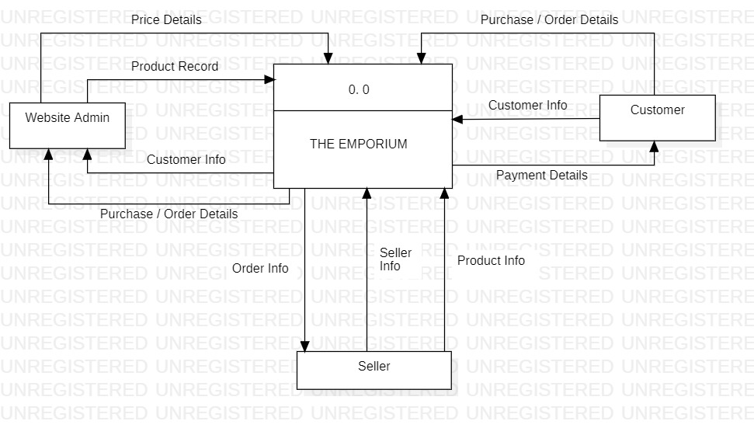

**Level 1 :** 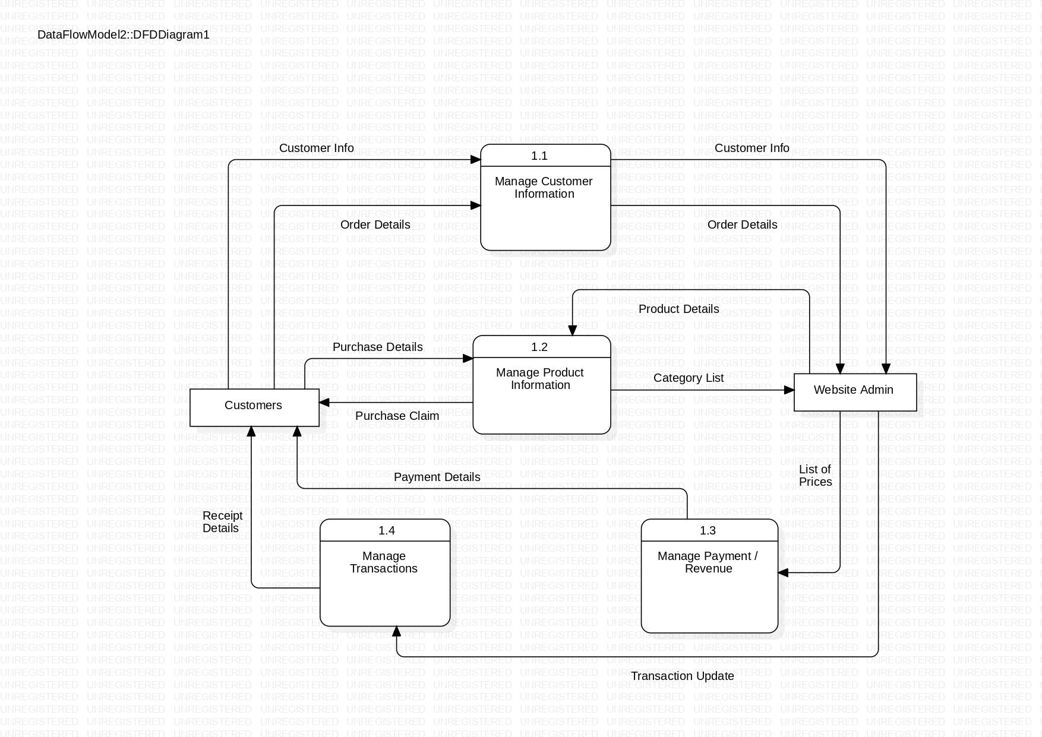

**Level 2 :**

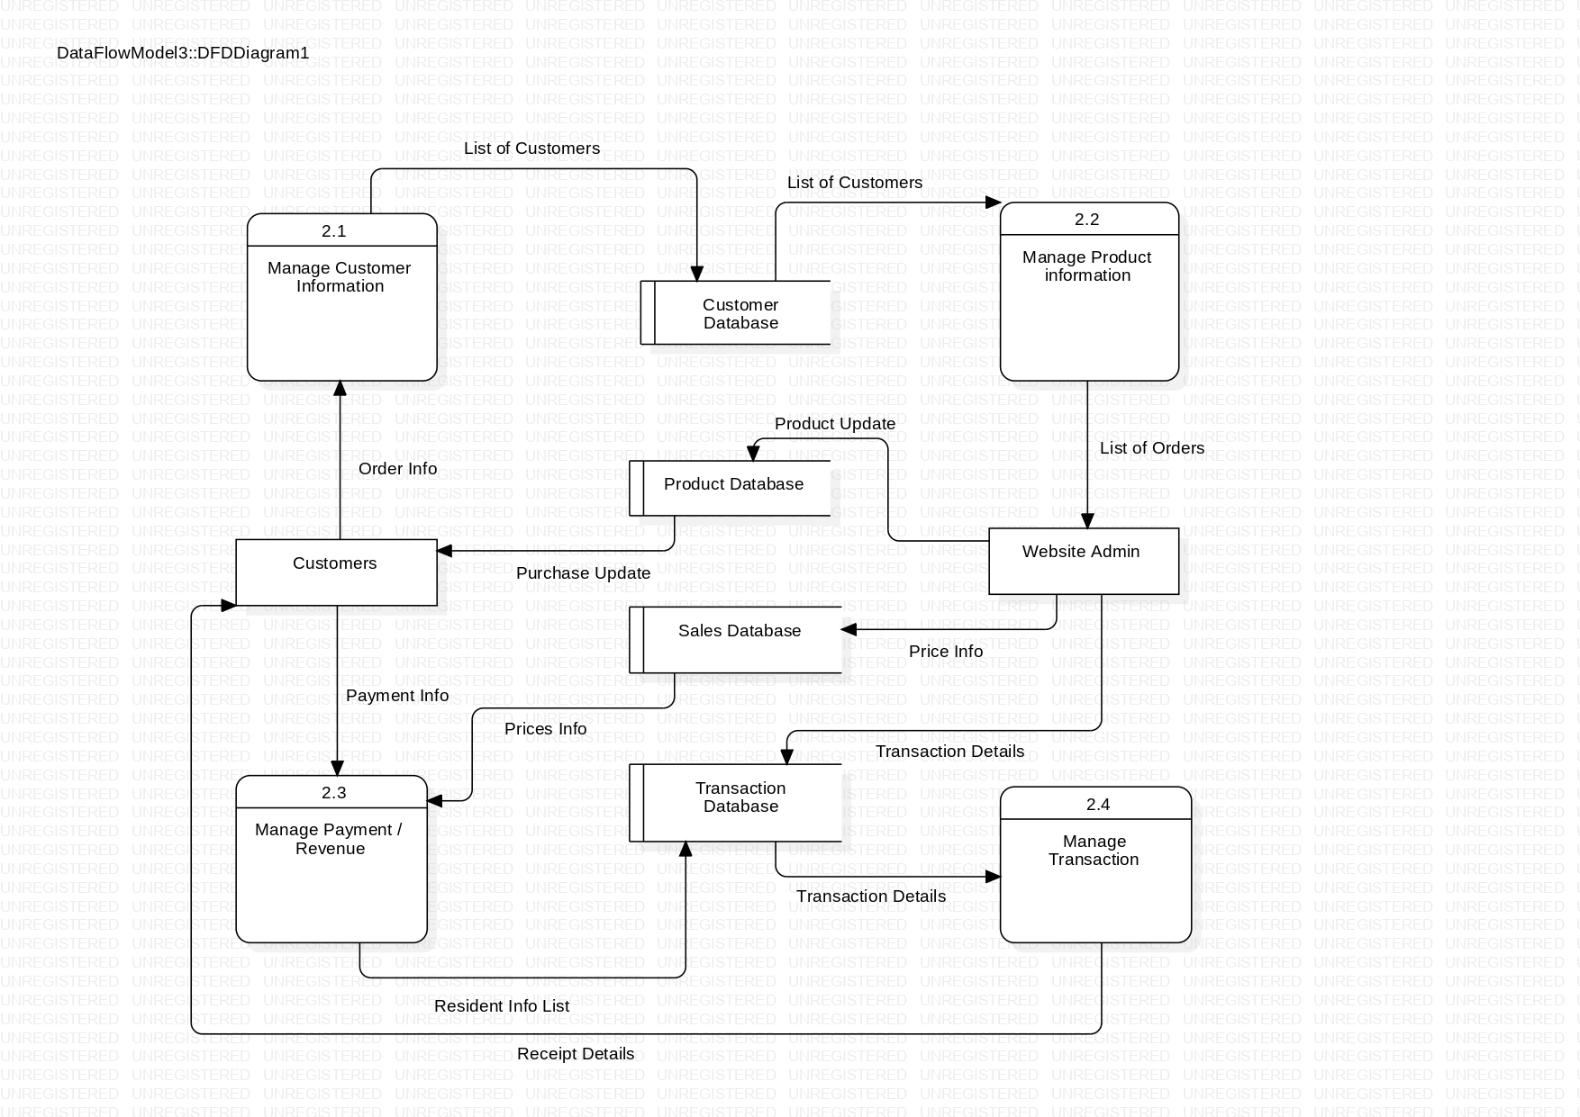

* 1. **Entity Relationship Diagram**

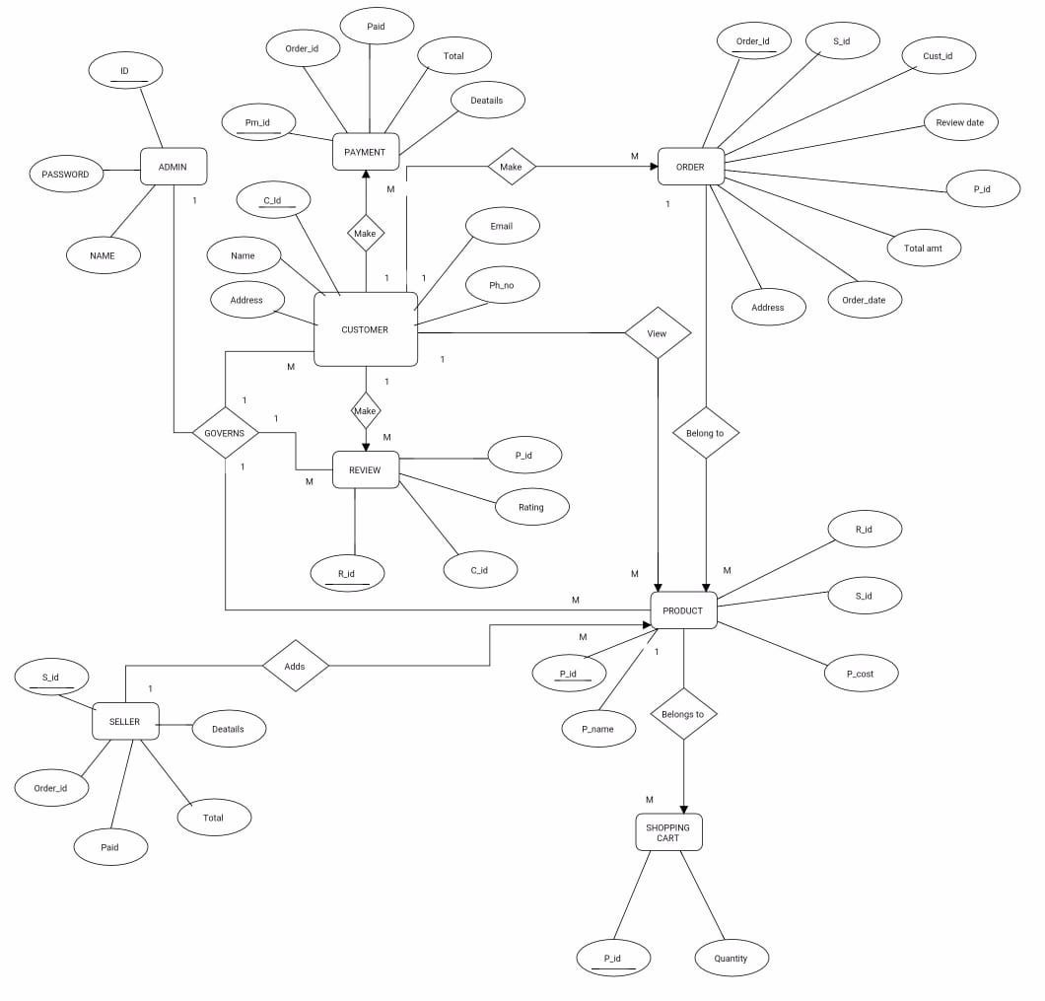

**2.3 Use Case Diagram**

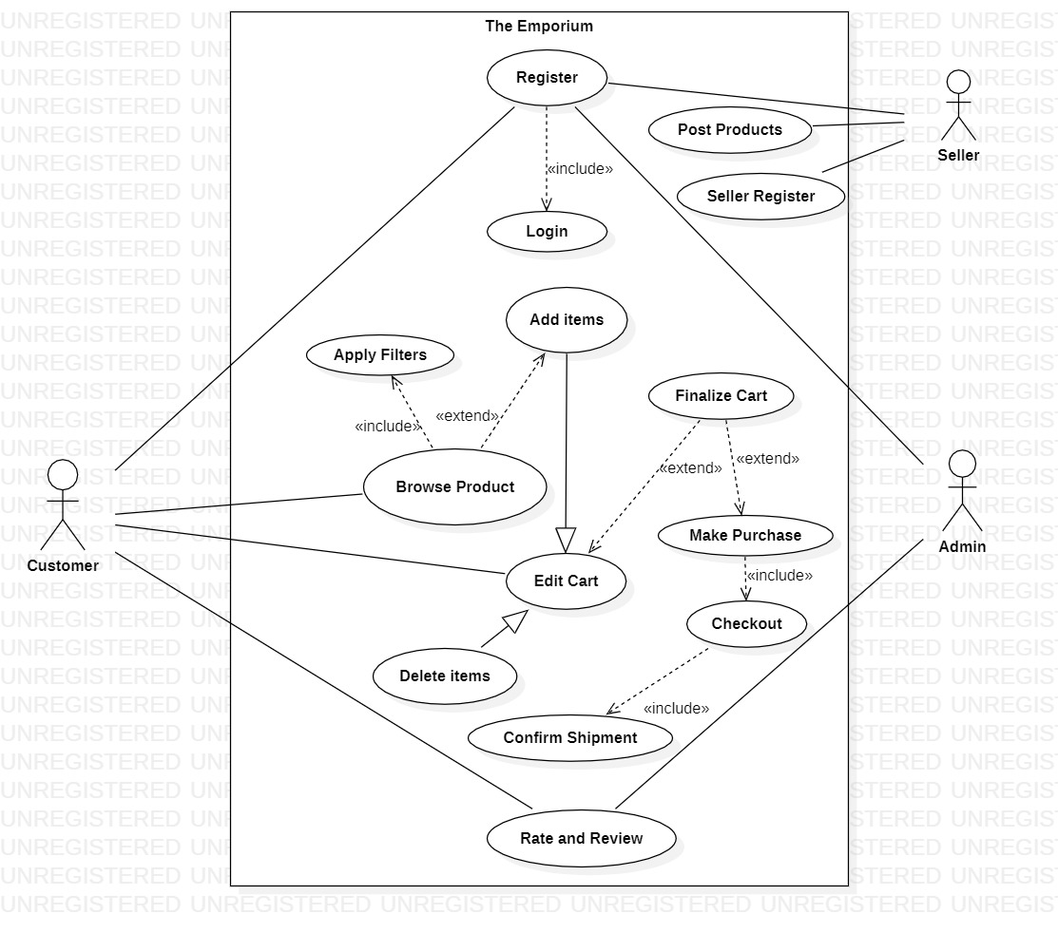

**2.4 Activity Diagram**

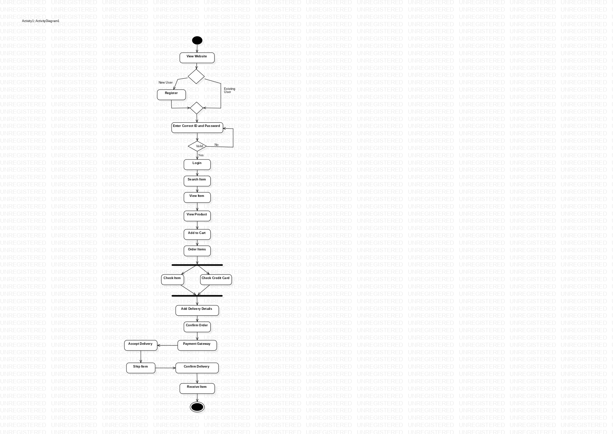

**2.5 Sequence Diagram**

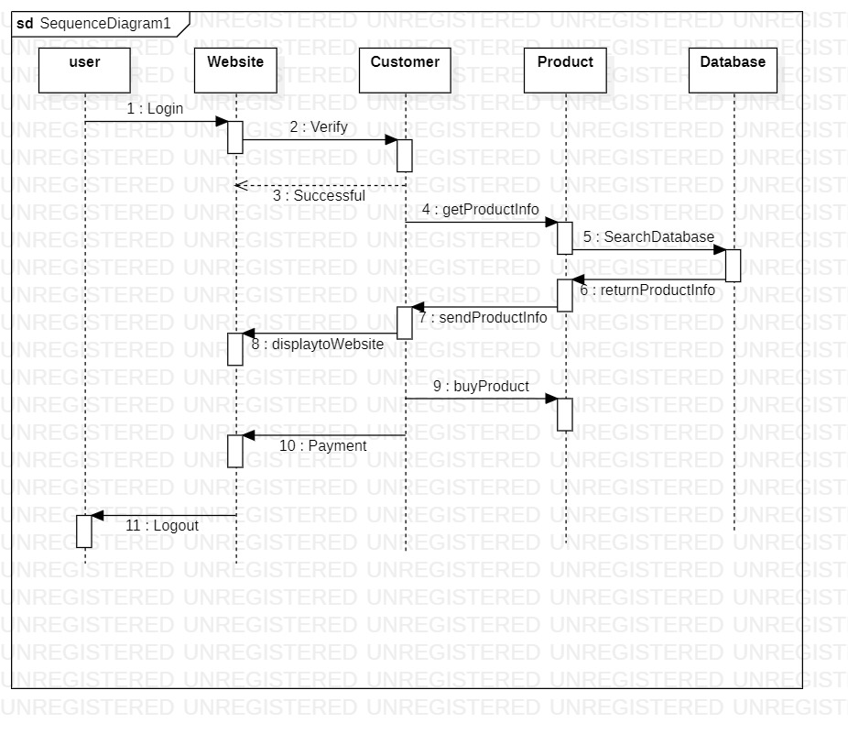

**2.6 Class Diagram**

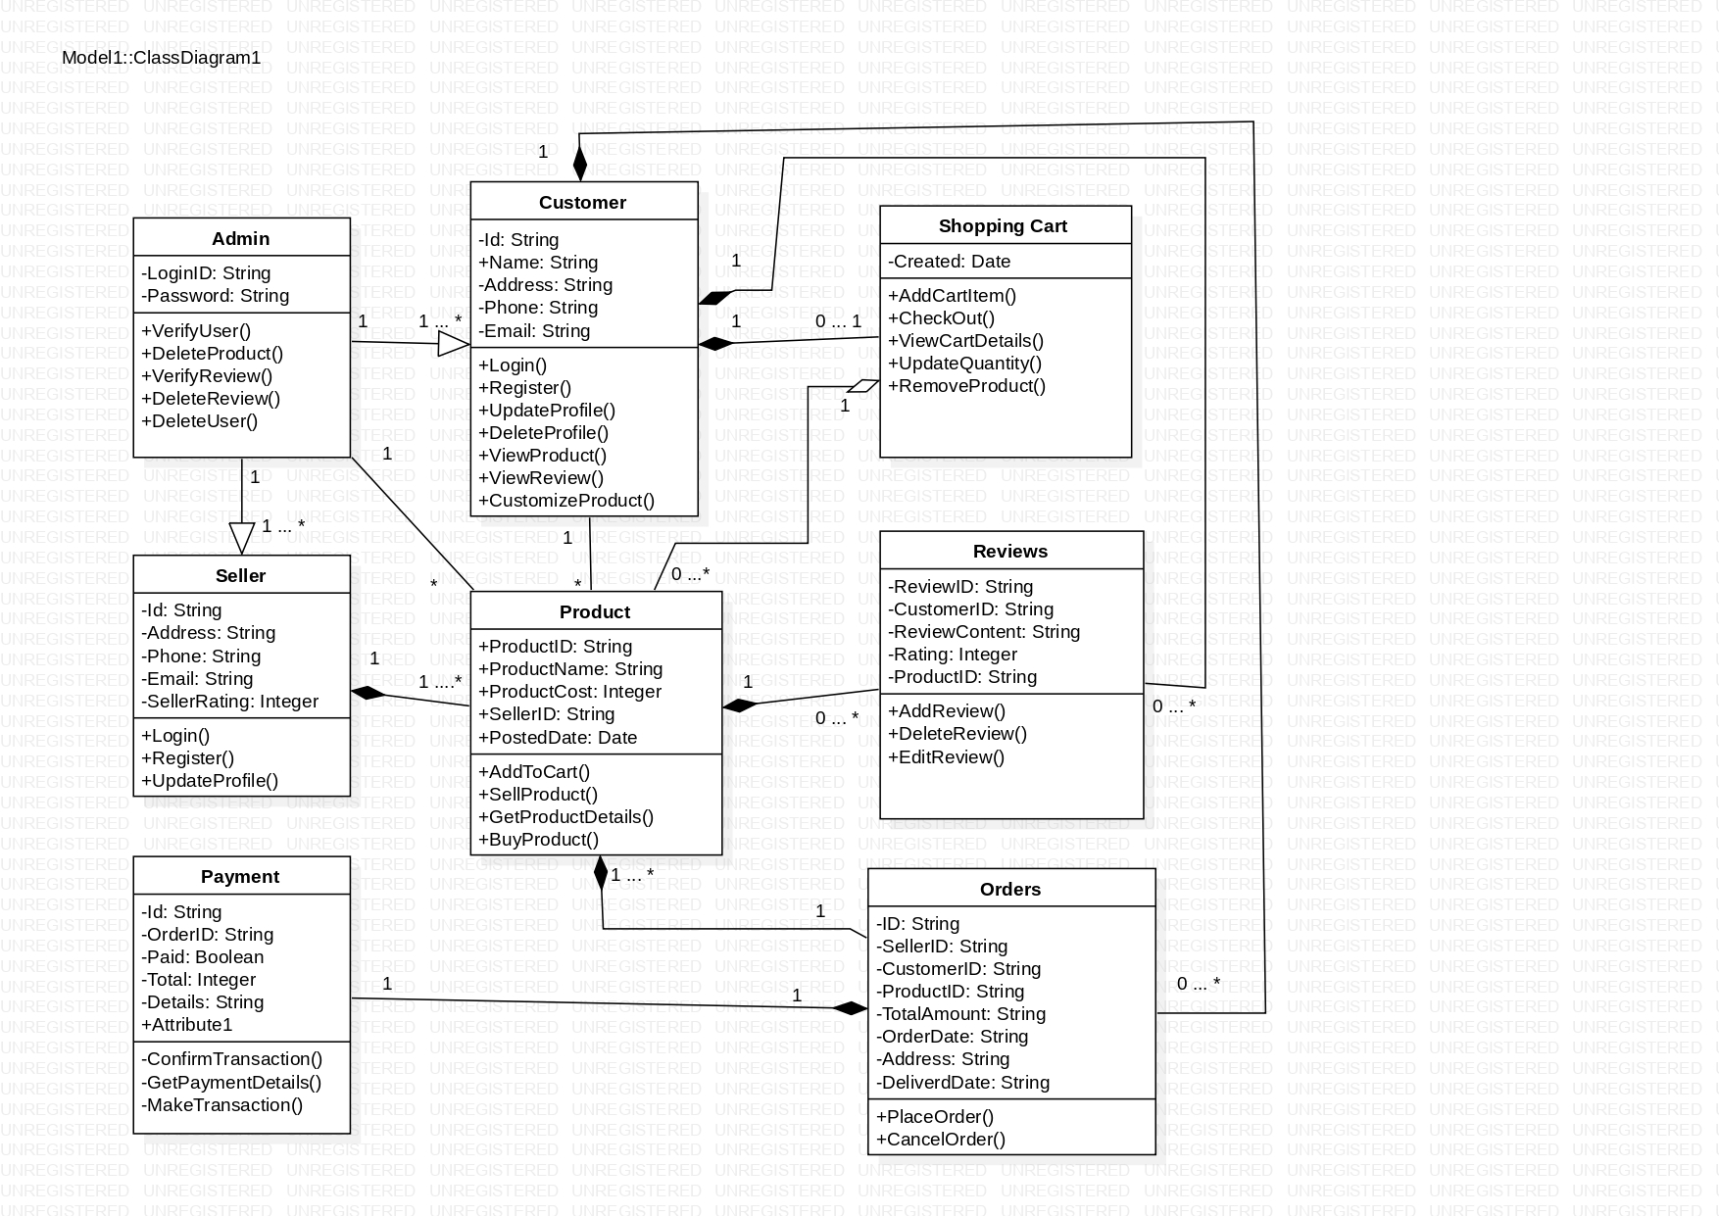

**2.7 User Interface Screens**

* **Admin Login :**

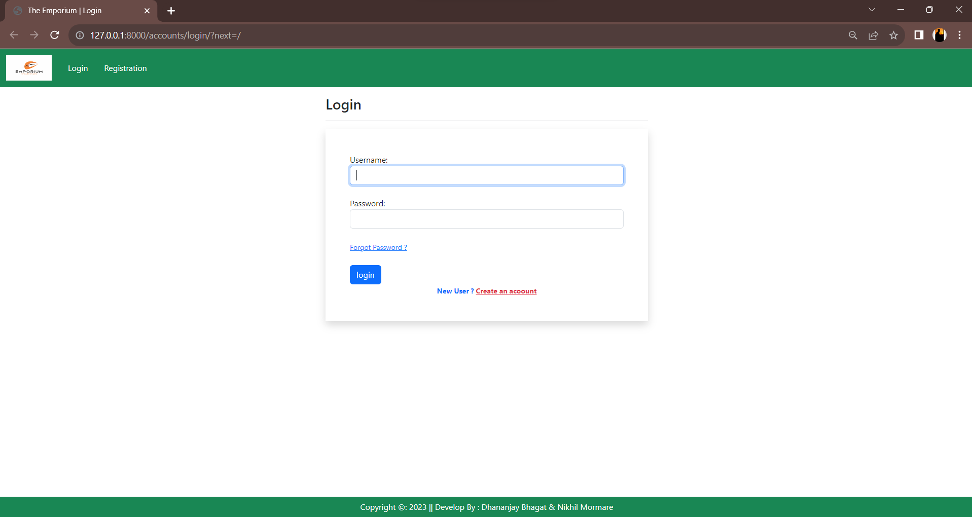

* **Customer Registration**

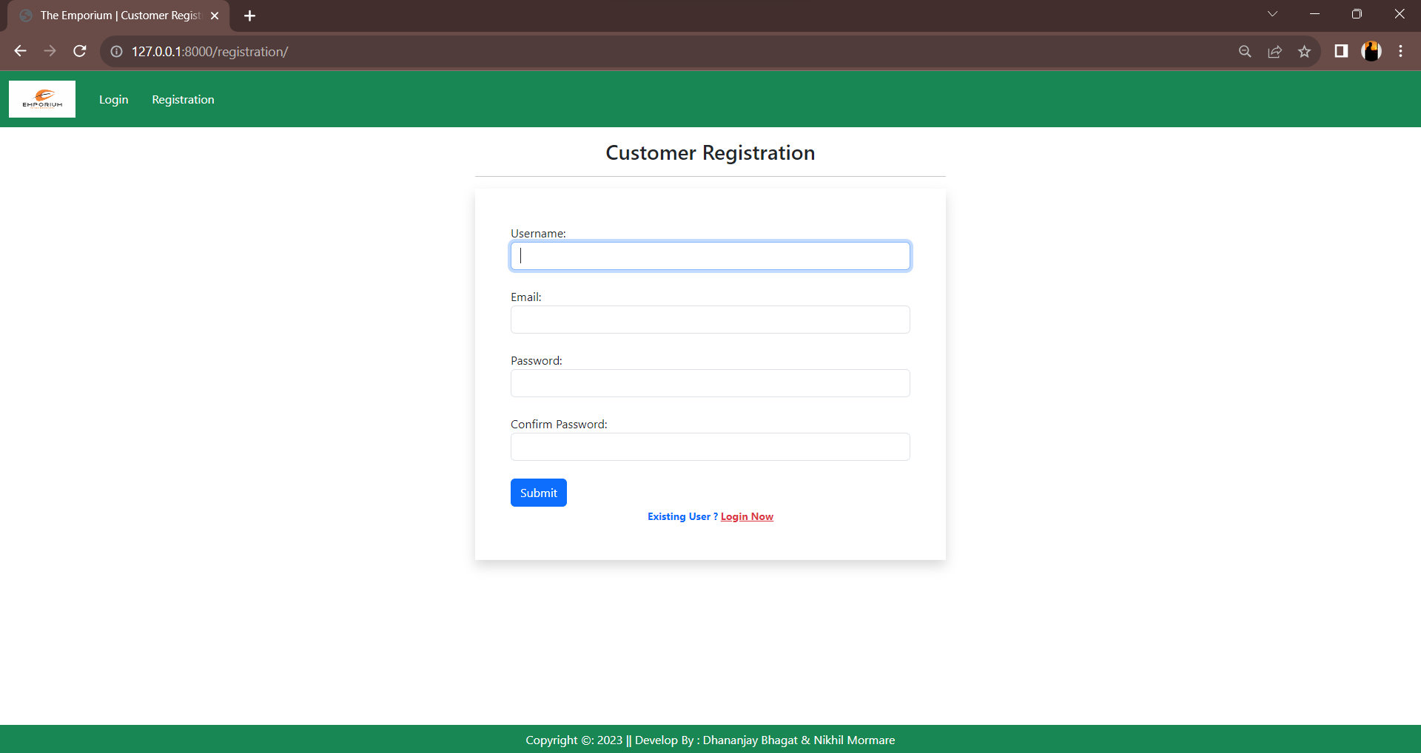

* **Dashboard :**

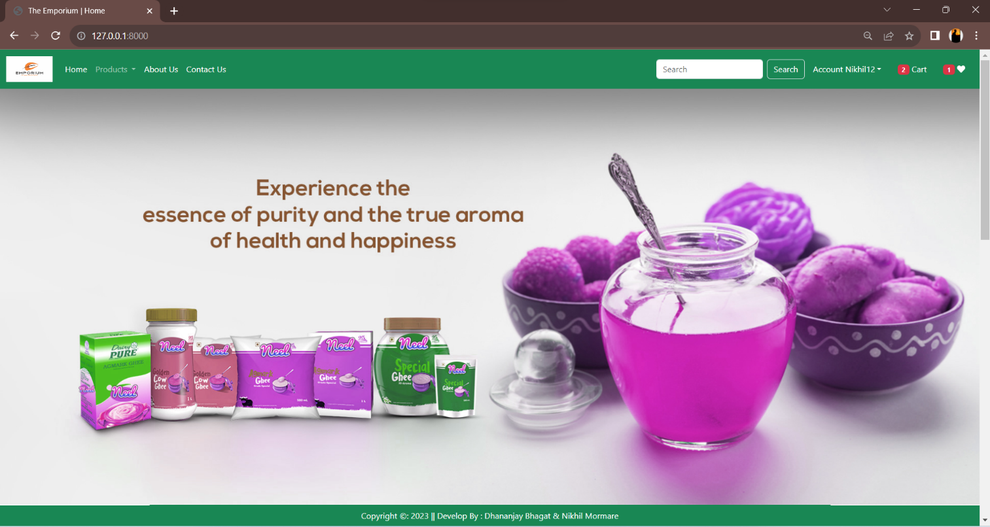

* **Purchase Product :**

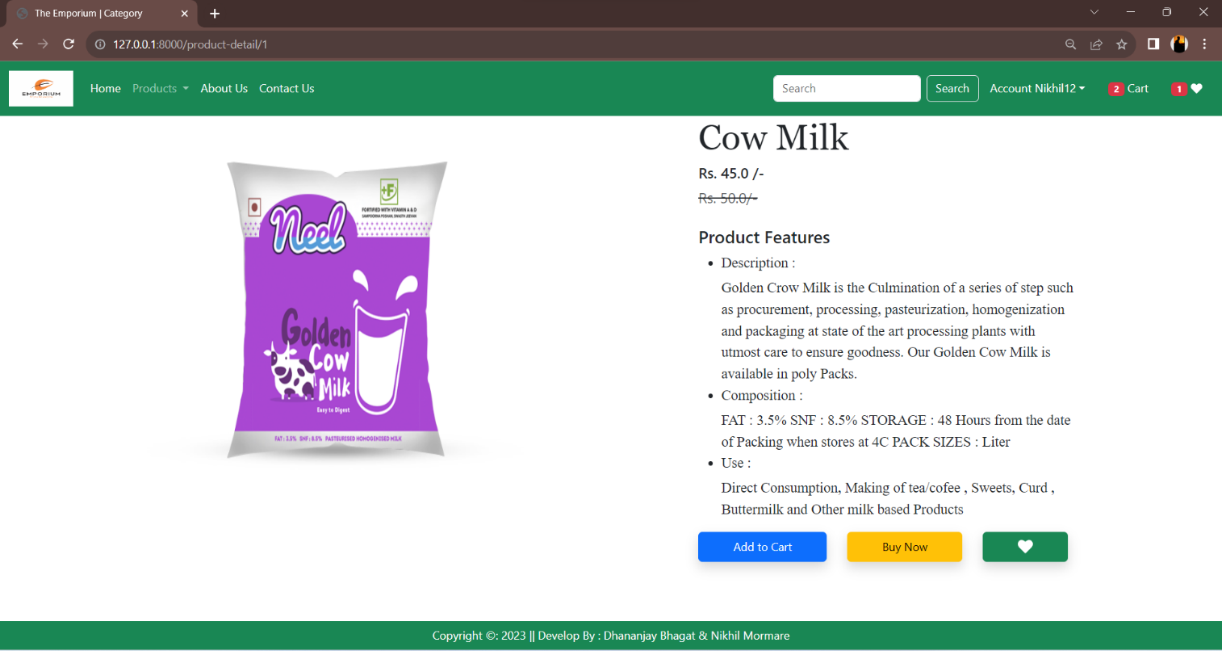

* **Customer Profile**

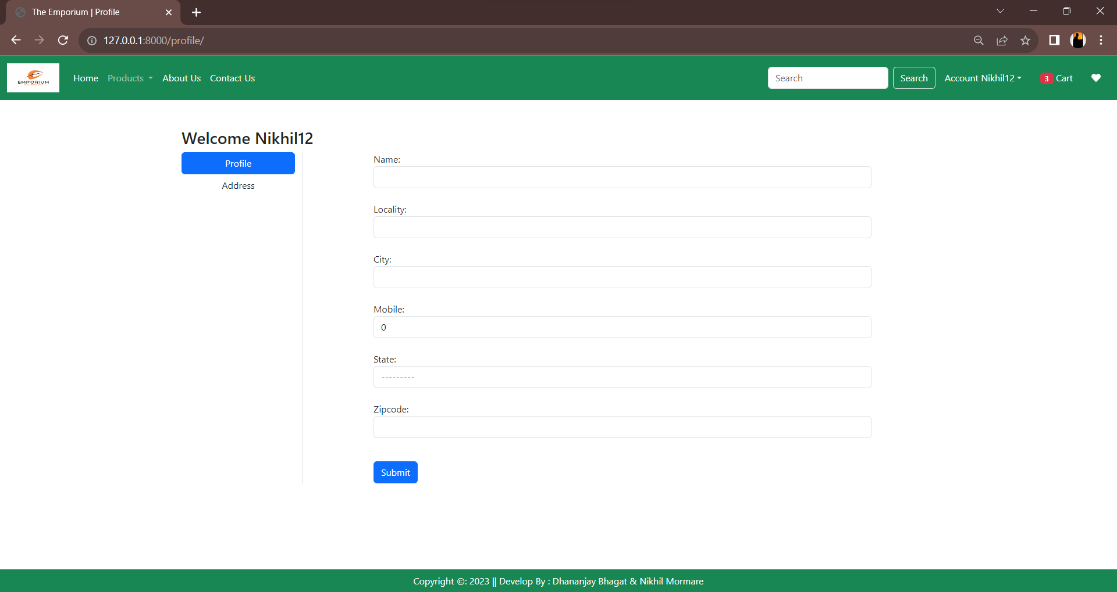

* **Shopping Cart**

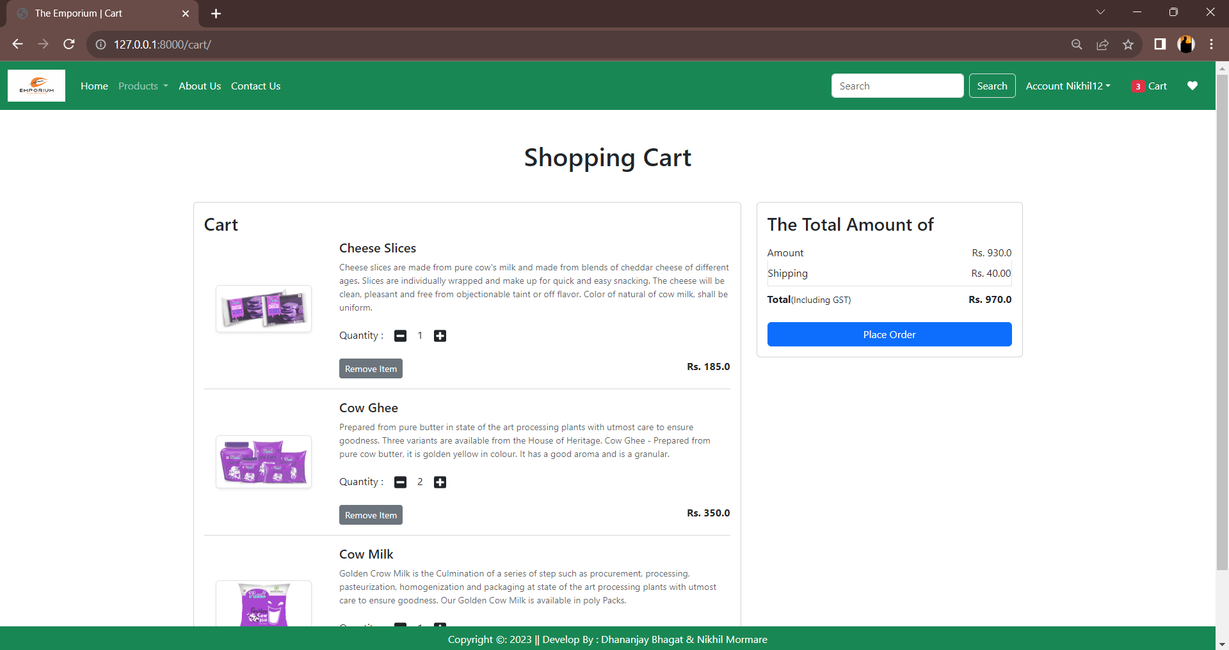

* **Checkout**

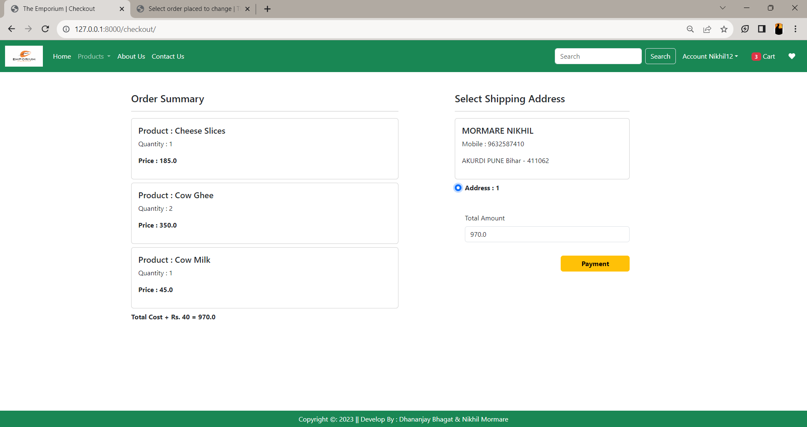

* **Order**

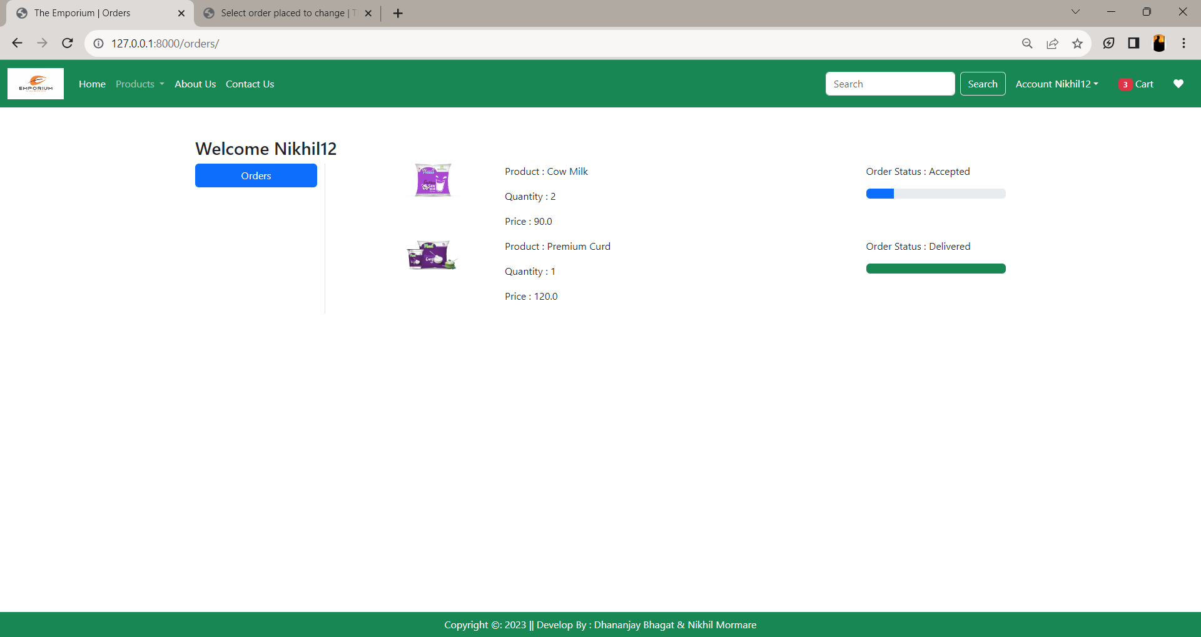

* **Product Category**

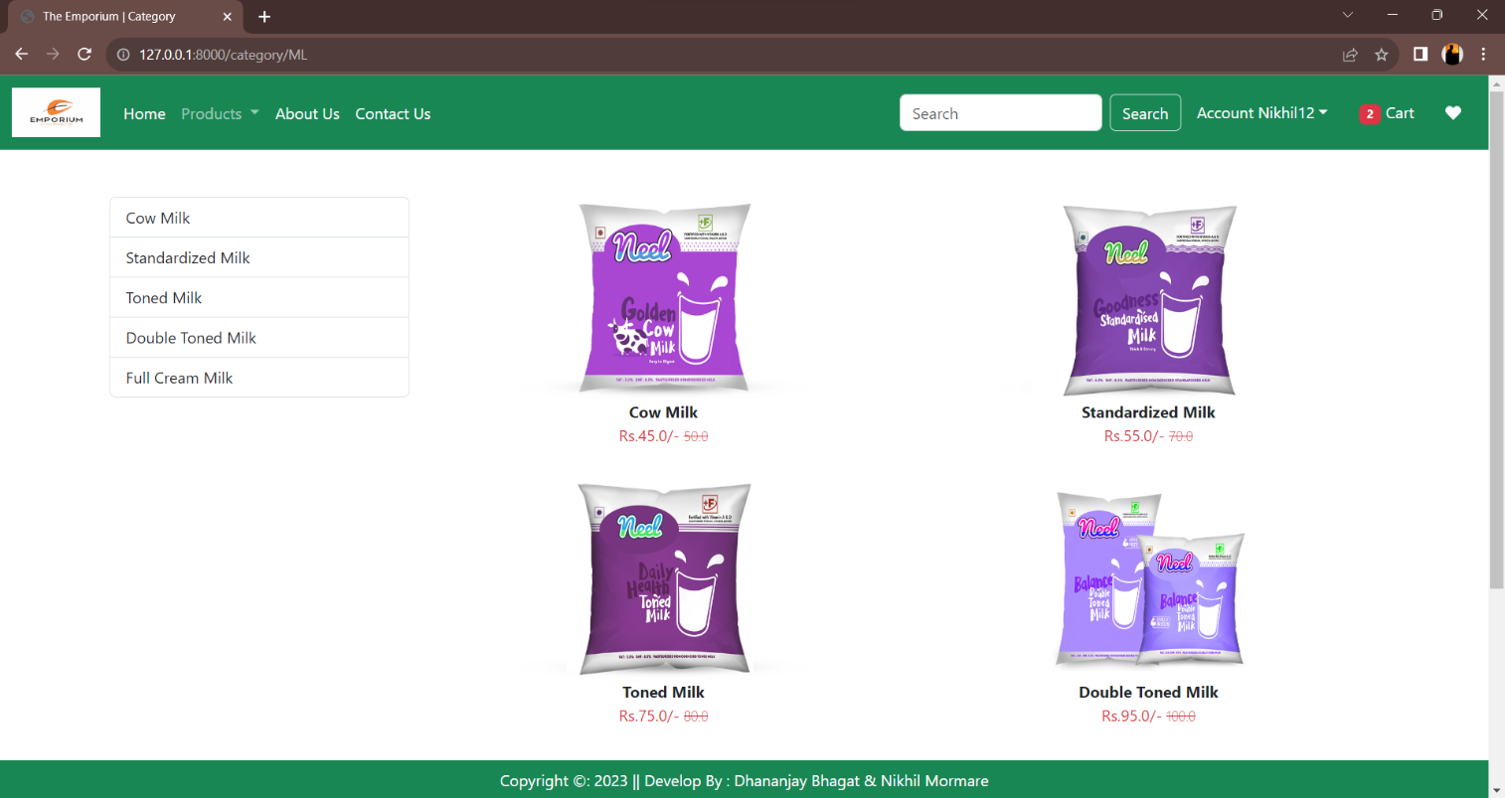

* **Payment**

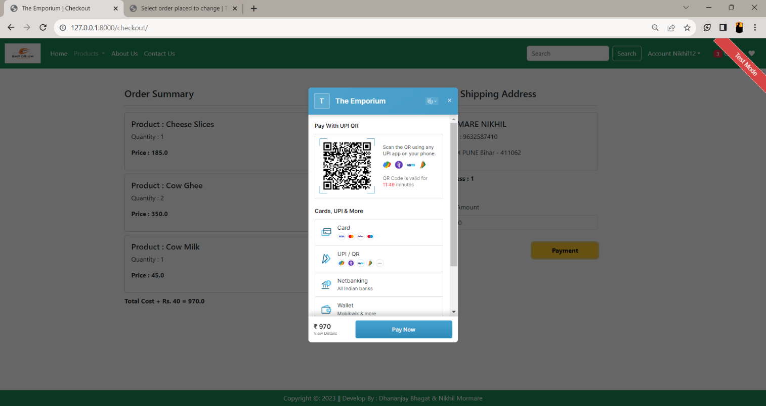

* **Change Password**

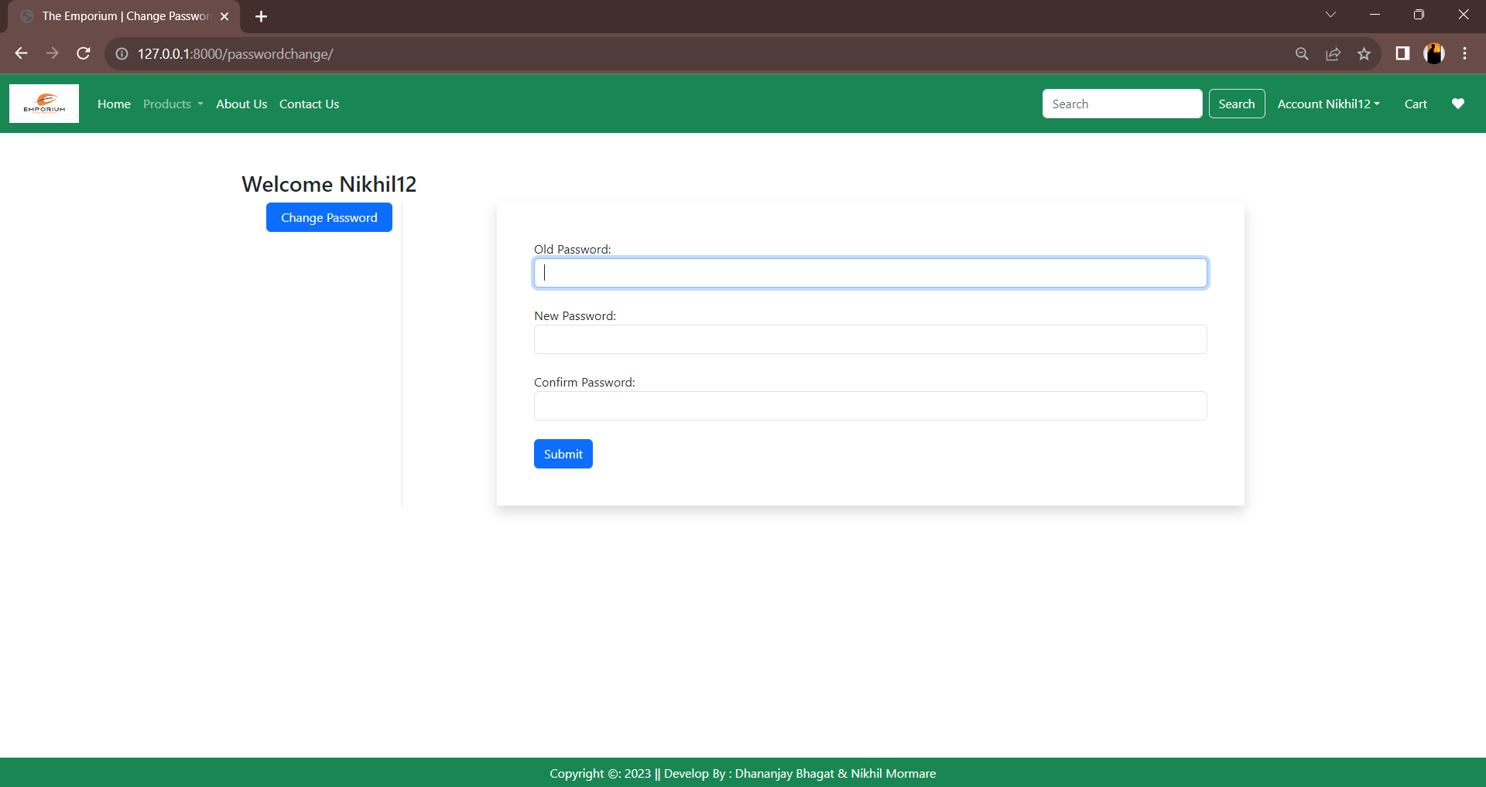

* **About Us**

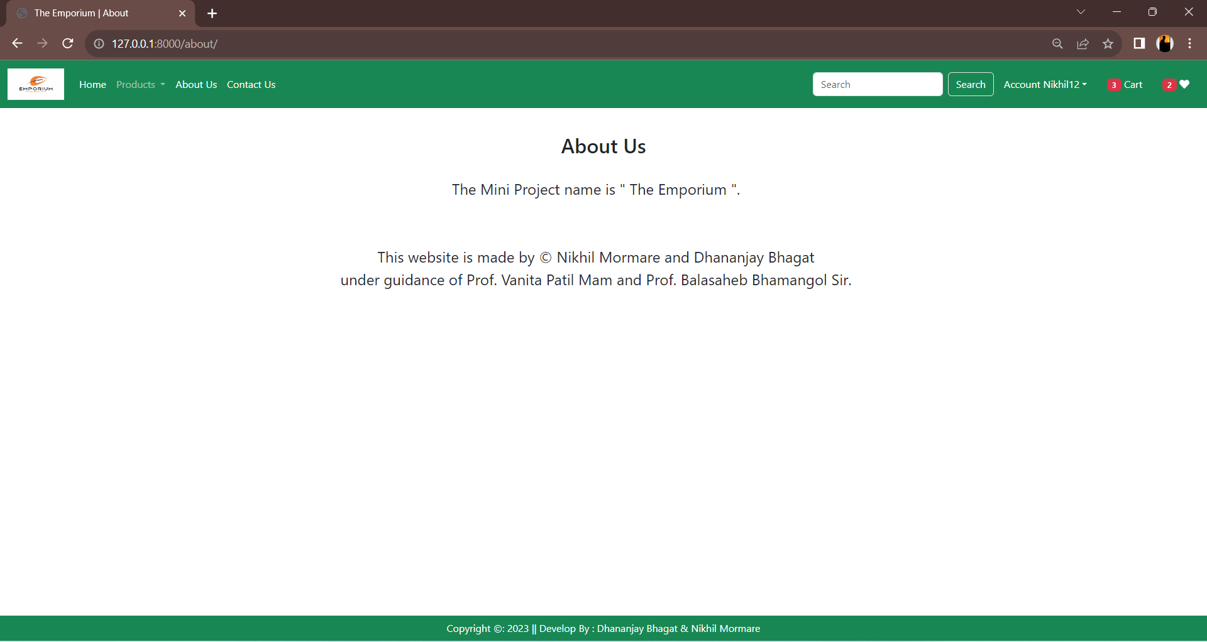

* **Contact Us**

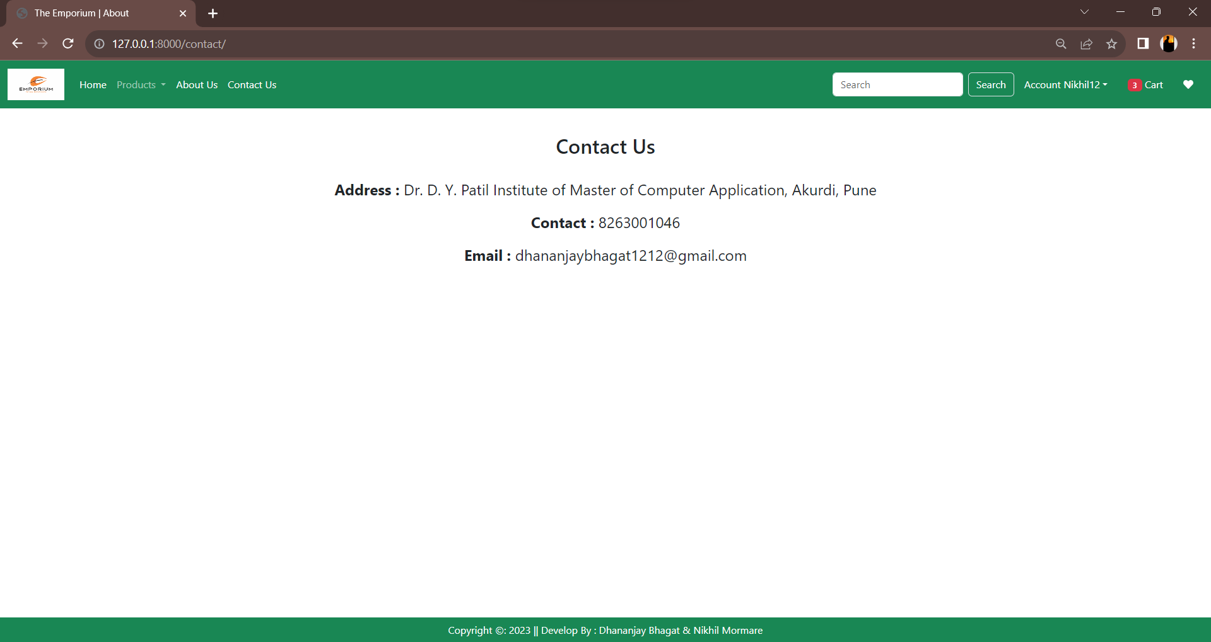

* **Search Product**

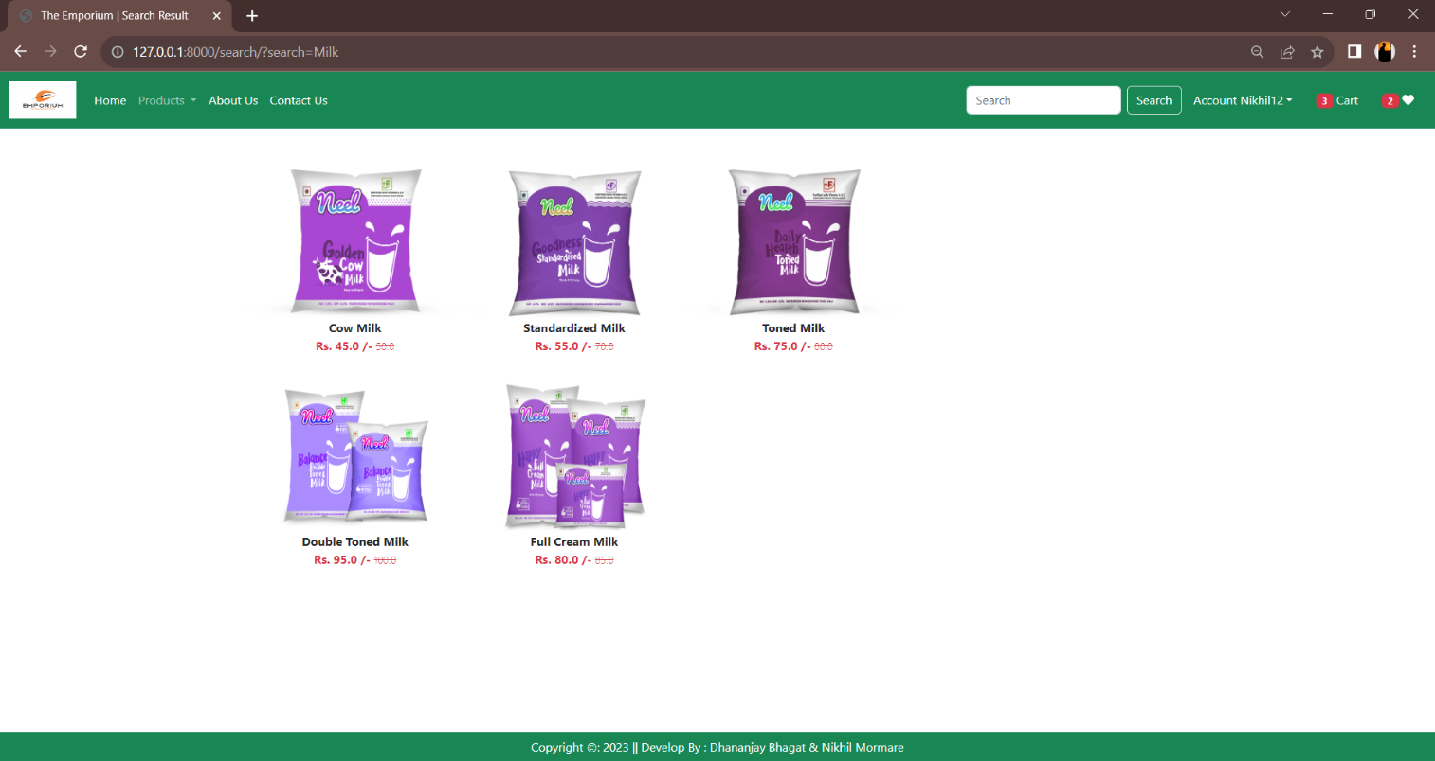

**2.8 Table Structure**

* **Admin Table**

|  |  |  |  |  |  |
| --- | --- | --- | --- | --- | --- |
| Sr.No | Field Name | Data Type | Size | Constraints | Description |
| 1 | Id | Integer | 100 | Primary Key | Admin Id |
| 2 | Uname | Varchar | 100 | Not Null | Admin Name |
| 3 | Password | Varchar | 100 | Not Null | Admin Password |

* **Product Detail Table**

|  |  |  |  |  |  |
| --- | --- | --- | --- | --- | --- |
| Sr.No | Field Name | Data Type | Size | Constraints | Description |
| 1 | Prod_id | Varchar | 100 | Primary key | Product Id |
| 2 | Prod_name | Varchar | 45 | Not Null | Product Name |
| 3 | Prod_qty | Integer | 45 | Not Null | Product Quantity |
| 4 | Prod_price | Integer | 45 | Not Null | Product Price |
| 5 | Prod_desc | Varchar | 200 | Not Null | Product Description |
| 6 | Seller_id | Varchar | 100 | Foreign Key | Seller Id |

* **Customer Table**

|  |  |  |  |  |  |
| --- | --- | --- | --- | --- | --- |
| Sr.No | Field Name | Data Type | Size | Constraints | Description |
| 1 | C_id | Varchar | 100 | Primary Key | Customer id |
| 2 | C_name | Varchar | 45 | Not Null | Customer Name |
| 3 | C_contact | Varchar | 45 | Not Null | Customer Contact |
| 4 | C_email | Varchar | 45 | Not Null | Customer Email id |
| 5 | C_address | Varchar | 45 | Not Null | Customer Address |
| 6 | C_Gender | Varchar | 45 | Not Null | Customer Gender |

* + **Seller Table**

|  |  |  |  |  |  |
| --- | --- | --- | --- | --- | --- |
| Sr.No | Field Name | Data Type | Size | Constraints | Description |
| 1 | Seller_id | Varchar | 100 | Primary Key | Seller id |
| 2 | Seller_name | Varchar | 45 | Not Null | Seller Name |
| 3 | Contact | Varchar | 45 | Not Null | Seller Contact |
| 4 | Email | Varchar | 45 | Not Null | Seller Email id |
| 5 | Address | Varchar | 45 | Not Null | Seller Address |

* + **Payment Table**

|  |  |  |  |  |  |
| --- | --- | --- | --- | --- | --- |
| Sr.No | Field Name | Data Type | Size | Constraints | Description |
| 1 | Payment_id | Varchar | 100 | Primary Key | Purchase id |
| 2 | Order_id | Varchar | 100 | Foreign Key | Seller id |
| 3 | Prod_id | Varchar | 100 | Foreign Key | Product id |
| 4 | Order_qty | Integer | 45 | Not Null | Order Quantity |
| 5 | Prod_price | Integer | 45 | Foreign Key | Product Price |

* + **Order Table**

|  |  |  |  |  |  |
| --- | --- | --- | --- | --- | --- |
| Sr.No | Field Name | Data Type | Size | Constraints | Description |
| 1 | Order_id | Varchar | 100 | Primary Key | Order id |
| 2 | C_id | Varchar | 100 | Foreign Key | Customer id |
| 3 | Prod_id | Varchar | 100 | Foreign Key | Product id |
| 4 | Prod_name | Varchar | 45 | Not Null | Product Name |
| 5 | Quantity | Integer | 45 | Not Null | Quantity |
| 6 | Prod_price | Integer | 100 | Not Null | Product Price |
| 7 | Total_amt | Integer | 100 | Not Null | Total Amount |
| 8 | Order date | Timestamp | 20 | Not Null | Current Timestamp |

* **Review table**

|  |  |  |  |  |  |
| --- | --- | --- | --- | --- | --- |
| Sr.No | Field Name | Data Type | Size | Constraints | Description |
| 1 | R_id | Varchar | 100 | Primary Key | Review id |
| 2 | C_id | Varchar | 100 | Foreign Key | Customer id |
| 3 | Prod_id | Varchar | 100 | Foreign key | Product id |
| 4 | Rating | Varchar | 200 | Not Null | Rating |

* **Cart**

|  |  |  |  |  |  |
| --- | --- | --- | --- | --- | --- |
| Sr.No | Field Name | Data Type | Size | Constraints | Description |
| 1 | C_id | Varchar | 100 | Foreign Key | Customer id |
| 2 | Prod_id | Varchar | 100 | Foreign Key | Product id |
| 3 | Quantity | Varchar | 45 | Not Null | Quantity |

**2.9 Analytical Report**

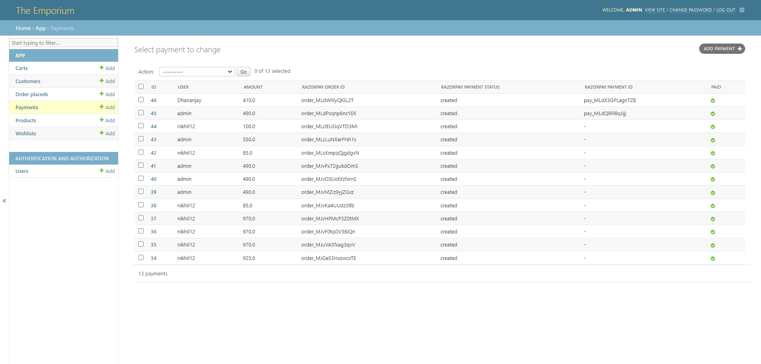

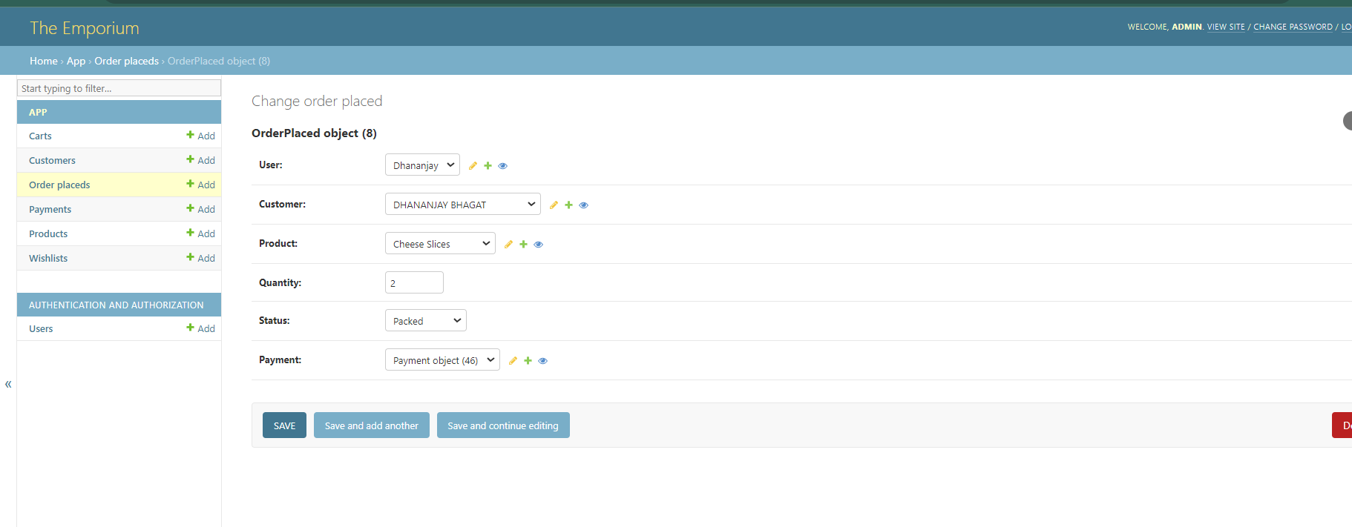

**CHAPTER 3 :**

**DRAWBACKS AND LIMITATIONS**

**3.Drawbacks And Limitations**

* Learning Curve: The system may have a learning curve for users who are not familiar with the software or technology. It may require training or assistance to effectively navigate and utilize all the features and functionalities.
* Initial Setup and Maintenance: Setting up the system and maintaining the infrastructure, such as the database and server, may require technical expertise. This can pose a challenge for small-scale dairy farms or facilities with limited resources.
* Data Security: While the system may have user authentication and access control features, data security can still be a concern. Without proper encryption or safeguards, sensitive information stored in the system, such as customer data or financial records, may be at risk of unauthorized access or data breaches.

**CHAPTER 4 :**

**PROPOSED ENHANCEMENT**

**4.Proposed Enhancement**

* Current system is developed according to current requirements which can be added later. In this, system can be merged with another system to make bigger system invoking many functions on it.
* No project is ever complete in itself; there are always minor or major changes in the project according to user requirements.
* This project could be enhanced in the sense that it can overcome its limitations in the future as sample scope for enhancement.
* Latest electronic and software technologies can help to bring in more enhancement which would help to make the system more user friendly and also help to maintain adequate security.
* To make the application as online so that it would be helpful to everyone.

**5 . Conclusion**

* We have tried to develop a system that can be a great help to the modern technological world to register the requirements and needs from user.
* We have left all the options open so that if there is any other future requirement in the system by the user for enhancement of the system then it is possible to implement them.
* The THE EMPORIUM initiates the objective of providing an organizer with customized and powerful operating operations and management system side is built with all the options like adding customer, vendor, product, shop, with features for updating them whenever necessary, report generation, purchase details, sales details and many more.
* The interface provided is user friendly, flexible. We hope that the project will serve its purpose for which it is developed, by underlining success of the project.

**6 . Bibliography**

* **Website Reference**
* <https://www.w3schools.com>
* <https://docs.djangoproject.com/>
* <https://realpython.com/>
* <https://www.wikipedia.org/>
* [www.geeksforgeeks.org](http://www.geeksforgeeks.org)
* **Books Reference**
* "Django for Beginners" by William S. Vincent
* "Two Scoops of Django 3.x" by Daniel Roy Greenfeld and Audrey Roy Greenfeld
* HTML Black Book

**ANNEXURE 3 : SAMPLE PROGRAM CODE**

1. **Coding of Home Page :**

<!DOCTYPE html>

{% load static %}

<html lang="en">

<head>

<meta charset="UTF-8">

<meta name="viewport" content="width=device-width, initial-scale=1.0">

<link href="https://cdn.jsdelivr.net/npm/bootstrap@5.3.0/dist/css/bootstrap.min.css" rel="stylesheet"

integrity="sha384-9ndCyUaIbzAi2FUVXJi0CjmCapSmO7SnpJef0486qhLnuZ2cdeRhO02iuK6FUUVM" crossorigin="anonymous">

<link rel="stylesheet" href="{% static 'app/css/owl.carousel.min.css' %}">

<link rel="stylesheet" href="{% static 'app/css/all.min.css' %}">

<link rel="stylesheet" href="{% static 'app/css/style.css' %}">

<script src="https://checkout.razorpay.com/v1/checkout.js"></script>

<title>The Emporium | {% block title %}{% endblock title %}</title>

</head>

<body>

<nav class="navbar navbar-expand-lg navbar-dark bg-success">

<div class="container-fluid">

<a class="navbar-brand" href="#">

<img src="{% static '\app\images\banner\product\emporiumlogo.png' %}" width="90" height="50"/>

</a>

<button class="navbar-toggler" type="button" data-bs-toggle="collapse" data-bs-target="#navbarSupportedContent"

aria-controls="navbarSupportedContent" aria-expanded="false" aria-label="Toggle navigation">

<span class="navbar-toggler-icon"></span>

</button>

<div class="collapse navbar-collapse" id="navbarSupportedContent">

<ul class="navbar-nav me-auto mb-2 mb-lg-0">

{% if request.user.is_authenticated %}

<li class="nav-item">

<a class="nav-link active" aria-current="page" href="/">Home</a>

</li>

<li class="nav-item dropdown">

<a class="nav-link dropdown-toggle" href="#" role="button" data-bs-toggle="dropdown"

aria-expanded="false">

Products

</a>

<ul class="dropdown-menu">

<li><a class="dropdown-item" href="{% url 'category' 'ML' %}">Milk</a></li>

<li><a class="dropdown-item" href="{% url 'category' 'CR' %}">Curd</a></li>

<li><a class="dropdown-item" href="{% url 'category' 'MS' %}">Milkshake</a></li>

<li><a class="dropdown-item" href="{% url 'category' 'LS' %}">Lassi</a></li>

<li><a class="dropdown-item" href="{% url 'category' 'GH' %}">Ghee</a></li>

<li><a class="dropdown-item" href="{% url 'category' 'PN' %}">Paneer</a></li>

<li><a class="dropdown-item" href="{% url 'category' 'CZ' %}">Cheese</a></li>

<li><a class="dropdown-item" href="{% url 'category' 'IC' %}">Ice-Creams</a></li>

</ul>

</li>

<li class="nav-item">

<a class="nav-link text-white" href="{% url 'about' %}">About Us</a>

</li>

<li class="nav-item">

<a class="nav-link text-white" href="{% url 'contact' %}">Contact Us</a>

</li>

</ul>

<form class="d-flex" role="search" action="/search">

<input class="form-control me-2" type="search" placeholder="Search" name="search" aria-label="Search">

<button class="btn btn-outline-success border text-white" type="submit">Search</button>

</form>

</div>

<ul class="navbar-nav me-auto mb-2 mb-lg-0">

<li class="nav-item dropdown mx-2">

<a class="nav-link dropdown-toggle text-white" href="#" id="profileDropdown" role="button"

data-bs-toggle="dropdown" aria-expanded="false">Account {{request.user.username|capfirst}}</a>

<ul class="dropdown-menu" aria-labelledby="profileDropdown">

<li><a class="dropdown-item" href="{% url 'profile' %}">Profile</a></li>

<li><a class="dropdown-item" href="{% url 'orders' %}">Orders</a></li>

<li><a class="dropdown-item" href="{% url 'passwordchange' %}">Change Password</a></li>

<li><a class="dropdown-item" href="{% url 'logout' %}">Logout</a></li>

</ul>

</li>

<li class="nav-item mx-2">

<a href="{% url 'showcart' %}" class="nav-link text-white"><span class="badge bg-danger">{% if totalitem > 0 %} {{totalitem}} {% endif %}</span> Cart</a>

</li>

<li class="nav-item mx-2">

<a href="{% url 'showwishlist' %}" class="nav-link text-white"><span class="badge bg-danger">{% if wishitem > 0 %} {{wishitem}} {% endif %}</span> <i class="fa fa-heart"></i></a>

</li>

{% else %}

<li class="nav-item mx-2">

<a href="{% url 'login' %}" class="nav-link text-white">Login</a>

</li>

<li class="nav-item mx-2">

<a href="{% url 'customerregistration' %}" class="nav-link text-white">Registration</a>

</li>

{% endif %}

</ul>

</div>

</nav>

{% block banner_slider %}{% endblock banner_slider %}

{% block information %}{% endblock information %}

{% block main-content %}{% endblock main-content %}

{% block payment-gateway %} {% endblock payment-gateway %}

<footer class="container-fluid bg-success fixed-bottom text-center text-white p-2 mt-5"> Copyright &copy: 2023 ||

Develop By : Dhananjay Bhagat & Nikhil Mormare

</footer>

<script src="https://cdn.jsdelivr.net/npm/@popperjs/core@2.11.8/dist/umd/popper.min.js"

integrity="sha384-I7E8VVD/ismYTF4hNIPjVp/Zjvgyol6VFvRkX/vR+Vc4jQkC+hVqc2pM8ODewa9r"

crossorigin="anonymous"></script>

<script src="https://cdn.jsdelivr.net/npm/bootstrap@5.3.0/dist/js/bootstrap.min.js"

integrity="sha384-fbbOQedDUMZZ5KreZpsbe1LCZPVmfTnH7ois6mU1QK+m14rQ1l2bGBq41eYeM/fS"

crossorigin="anonymous"></script>

<script src="https://cdnjs.cloudflare.com/ajax/libs/jquery/3.7.0/jquery.min.js"></script>

<script src="{% static 'app/js/owl.carousel.min.js' %}"></script>

<script src="{% static 'app/js/all.min.js' %}"></script>

<script src="{% static 'app\js\myscript.js' %}"></script>

</body>

</html>

1. **Coding of Login Page :**

{% extends 'app/base.html' %}

{% load static %}

{% block title %}Login{% endblock title %}

{% block main-content %}

<div class="container">

<div class="row my-3">

<div class="col-sm-6 offset-sm-3">

<h3>Login</h3>

<hr>

<form action="" method="post" novalidate class="shadow p-5">

{% csrf_token %}

{% for fm in form %}

{{fm.label_tag}} {{fm}} <small class="text-danger">{{fm.errors|striptags}}</small><br>

{% endfor %}

<small><a href="{% url 'password_reset' %}">Forgot Password ?</a></small><br>

<input type="submit" class="btn btn-primary mt-4" value="login">

<div class="text-center text-primary fw-bold">

<small>New User ? <a href="{% url 'customerregistration' %}" class="text-danger">Create an

acoount</a></small>

</div>

{% if form.non_field_errors %}

{% for error in form.non_field_errors %}

<p class="alert alert-danger my-3">{{error}}</p>

{% endfor %}

{% endif %}

</form>

</div>

</div>

</div>

{% endblock main-content %}

1. **Coding of Product Detail Page :**

{% extends 'app/base.html' %}

{% load static %}

{% block title %}Category{% endblock title %}

{% block main-content %}

<div class="container">

<div class="row flex justify-content-between">

<div class="img2 col-lg-5 mt-5">

<img src="{{product.product_images.url}}"

class="image col-xs-6 col-sm-12 col-lg-12 mt-3 text-sm-center w-100 h-75" alt="">

</div>

<div class="productdetail col-lg-5">

<h1 style="font-family: Georgia; font-size :50px;">{{product.title}}</h1>

<h5> Rs. {{product.discounted_price}} /-</h5>

<small class="text-decoration-line-through text-muted fs-5">

<del>Rs. {{product.selling_price}}/-</del>

</small>

<br><br>

<h4>Product Features</h4>

<ul class="fs-5" style="font-family : Rajdhani;">

<li><h5>Description : </h5>{{product.description}}</li>

<li><h5>Composition : </h5> {{product.composition}}</li>

<li><h5>Use : </h5> {{product.prodapp}}</li>

</ul>

<form action="/add-to-cart" class="d-inline">

<input type="hidden" name="prod_id" value="{{product.id}}"/>

<button type="submit"

class="btn btn-primary shadow px-5 py-2">Add to Cart

</button>

</form>

<a href="{% url 'showcart' %}" class="btn btn-warning shadow px-5 py-2 ms-4">Buy Now</a>

{% if wishlist %}

<a pid={{product.id}} class="minus-wishlist btn btn-danger shadow px-5 py-2 ms-4"><i

class="fas fa-heart fa-lg"></i></a>

{% else %}

<a pid={{product.id}} class="plus-wishlist btn btn-success shadow px-5 py-2 ms-4"><i

class="fas fa-heart fa-lg"></i></a>

{% endif %}

</div>

</div>

</div>

{% endblock main-content %}